User manual



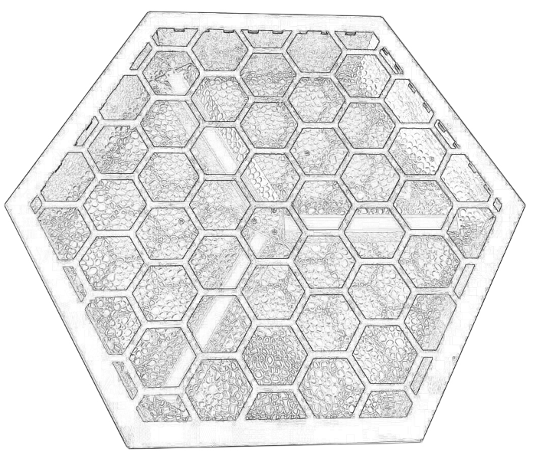
P3 RETRO LIGHT
Please read the instructions carefully before use

TABLE OF CONTENTS
- Safety Instructions………………………………………………………………………………3-4
- Technical Specifications…………………………………………………………………………4
- Control Menu ………………………………………………………………………………………5
- DMX Channels ……………………………………………………………………………………6-7
- Trouble Shooting……………………………………………………………………………………8
- Fixture Cleaning………………………………………………………… …………………………8

STATEMENT
The product has well capability and intact packing when leave factory. All of the user should comply with warning item and manual, any misuse cause of the damages are not included in our guarantee, and also can not be responsible for any malfunction & problem owing to ignore the manual.

1.Safety Instructions
Please keep this User Guide for future consultation. If you sell the unit to another user, be sure that they also receive this instruction booklet.
•Unpack and check carefully there is no transportation damage before using the unit.
•Before operating, ensure that the voltage and frequency of power supply match the power requirements of the unit.
•It’s important to ground the yellow/green conductor to earth in order to avoid electric shock.
•The unit is for indoor use only. Use only in a dry location.
•The unit must be installed in a location with adequate ventilation, at least 50cm from adjacent surfaces. Be sure that no ventilation slots are blocked.
•Disconnect main power before replacement or servicing.
•Make sure there are no flammable materials close to the unit while operating as it is fire hazard.
•Use safety cable when fixes this unit. DO NOT handle the unit by taking its head only, but always by taking its base.
•Maximum ambient temperature is Ta: 40℃. DO NOT operate it where the temperature is higher than this Unit surface temperature may reach up to 85℃. DO NOT touch the housing bare-hand during its operation. Turn off the power and allow about 15 minutes for the unit to cool down before replacing or serving.
•the event of serious operating problem, stop using the unit immediately.Never try to repair the unit by yourself. Repairs carried out by unskilled people can lead to damage or malfunction. Please contact the nearest authorized technical assistance center. Always use the same type spare parts.
•DO NOT touch any wire during operation as high voltage might be causing electric shock.
Warning:
•To prevent or reduce the risk of electrical shock or fire, do not expose the unit to rain or moisture.
•The housing, the lenses, or the ultraviolet filter must be replaced if they are visibly damaged.
Caution:
•There are no user serviceable parts inside the unit. DO NOT open the housing or attempt any repairs yourself. In the unlikely event your unit may require service, please contact your nearest dealer.
Installation:
•The unit should be mounted via its screw holes on the bracket. Always ensure that the unit is firmly fixed to avoid vibration and slipping while operating. And make sure that the structure to which you are attaching the unit is secure and is able to support a weight of 10 times of the unit’s weight. Also always use a safety cable that can hold 12 times of the weight of the unit when installing the fixture.
•The equipment must be fixed by professionals. And it must be fixed at a place where is out of the touch of people.

2.Technical Specifications
SPECIFICATIONS:
Light Source: 3*60W white & 72*0.3w RGB led
Input Voltage:AC90-260V 50/60Hz
Power Consumption: 250W
Control mode:DMX512,Auto-run , Master-Slave,RDM
Control Channel: 4/14/147 channels
PowerCon : powerCon in & out
DMX sockets:3-pin XLR sockets
Display: Digital Display
Strobe：1-30Hz multiple stroboscopic effect
Dimming：32bit 0-100% linear dimmer

3.Control Menu
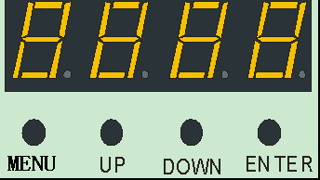

Menu Operation
On the base of the control panel offers a number of features, such as setting DMX fixture address, switch the lamp, run the test program, the mode selection.
No | Show | Instruction
1 | A001 A512 | 001-512
2 | Channel | 4CH
2 | Channel | 14CH
2 | Channel | 147CH
3 | N127 | Fill light effect mode
4 | S000 S255 | Modify the auxiliary light effect running speed up or down (S000~S255)
5 | E007 | Intermediate key light mode
6 | S000 S255 | Modify the running speed of the intermediate main light up or down (S000~S255)
7 | Sound | Sound
8 | R255 R000 | R dimmer
9 | G255 G000 | G dimmer
10 | B255 B000 | B dimmer
11 | W255 W000 | W dimmer
12 | T000 | Display temperature, such as T045 means the current lamp temperature is 45℃

4.DMX Channels
4 DMX channels
CH 4 | DMX Value | Function | Function Illustration
1 | 0-255 | Red | R Dimmer dark to light
2 | 0-255 | Green | G Dimmer dark to light
3 | 0-255 | Blue | B Dimmer dark to light
4 | 0-255 | White | W Dimmer dark to light
14 DMX channels
CH 14 | DMX Value | Function | Function Illustration
1 | 0－255 | Total Dimmer | Total Dimmer
2 | 0－9 | Strobe | No function
2 | 10－255 | Strobe | Slow to fast
3 | 0-255 | Red | R Dimmer dark to light
4 | 0-255 | Green | G Dimmer dark to light
5 | 0-255 | Blue | B Dimmer dark to light
6 | 0-255 | RGB Effect | 2 values and one effect
7 | 0-127 | RGB Speed | positive
7 | 128-255 | RGB Speed | reverse
8 | 0-255 | RGB background color | RGB background color
9 | 0-255 | RGB background Dimmer | RGB background Dimmer
10 | 0-255 | White Dimmer | White Dimmer dark to light
11 | 0-255 | White Strobe | White Strobe slow to fast
12 | 0-255 | White Liner Dimmer | White Liner Dimmer dark to light
13 | 0-255 | White Effect | 32 values for one effect
14 | 0-255 | White speed | fast to slow
147 DMX channels
CH 147 | DMX Value | Function | Function Illustration
1 | 0-255 | Red1 | Red1 Liner Dimmer
2 | 0-255 | Green1 | Green1 Liner Dimmer
3 | 0-255 | Blue1 | Blue1 Liner Dimmer
4 | 0-255 | Red2 | Red2 Liner Dimmer
5 | 0-255 | Green2 | Green2 Liner Dimmer
6 | 0-255 | Blue2 | Blue2 Liner Dimmer
7 | 0-255 | Red3 | Red3 Liner Dimmer
8 | 0-255 | Green3 | Green3 Liner Dimmer
9 | 0-255 | Blue3 | Blue3 Liner Dimmer
… | 0-255 | … | …
136 | 0-255 | Red46 | Red46 Liner Dimmer
137 | 0-255 | Green46 | Green46 Liner Dimmer
138 | 0-255 | Blue46 | Blue46 Liner Dimmer
139 | 0-255 | Red47 | Red47 Liner Dimmer
140 | 0-255 | Green47 | Green47 Liner Dimmer
141 | 0-255 | Blue47 | Blue47 Liner Dimmer
142 | 0-255 | Red48 | Red48 Liner Dimmer
143 | 0-255 | Green48 | Green48 Liner Dimmer
144 | 0-255 | Blue48 | Blue48 Liner Dimmer
145 | 0-255 | White1 | White1 Liner Dimmer
146 | 0-255 | White2 | White2 Liner Dimmer
147 | 0-255 | White3 | White3 Liner Dimmer

EFFECT Mode
NO | DMX Value | Function
0 | 0-7 | No function
1 | 8-15 | Effect 1
2 | 16-23 | Effect 1
3 | 24-31 | Effect 3
4 | 32-39 | Effect 4
… | … … | … …
29 | 232-239 | Effect 29
30 | 240-247 | Effect 1-29 cycle
31 | 248-255 | Sound

5.Trouble Shooting
Following are a few common problems that may occur during operation. Here are some suggestions for easy troubleshooting:

A. The unit does not work, no light and the fan does not work
1. Check the connection of power and main fuse.
2. Measure the mains voltage on the main connector.
3. Check the power on LED.

B. Not responding to DMX controller
1. DMX LED should be on. If not, check DMX connectors, cables to see if link properly.
2. If the DMX LED is on and no response to the channel, check the address settings and DMX polarity.
3. If you have intermittent DMX signal problems, check the pins on connectors or on
PCB of the unit or the previous one.
4. Try to use another DMX controller.
5. Check if the DMX cables run near or run alongside to high voltage cables that may cause damage or interference to DMX interface circuit.
C. One of the channels is not working well
1. The stepper motor might be damaged or the cable connected to the PCB is broken.
2. The motor’s drive IC on the PCB might be out of condition
6.Fixture Cleaning
The cleaning of internal and external optical lenses and/or mirrors must be carried out periodically to optimize light output. Cleaning frequency depends on the environment in which the fixture operates: damp, smoky or particularly dirty surrounding can cause greater accumulation of dirt on the unit’s optics.
• Clean with soft cloth using normal glass cleaning fluid.
• Always dry the parts carefully.
• Clean the external optics at least every 20 days. Clean the internal optics at least every 30/60 days.

